
Deccan Education Society’s
Fergusson College (Autonomous), Pune

Department of Computer Science

A Report

On

“A* algorithm”

In partial fulfillment of Post Graduate course

in

M.Sc. Computer Science – I

(Semester -II)

CSC-570 Practical III

SUBMITTED BY

KARAN KAPSE (ROLL NO –236227)

ABHIJEET LOKHANDE (ROLL NO –236229)

GANESH SOLAT (ROLL NO –236258)

Index

Sr. No | Table of Content | Page No
1 | Case Study description  (Algorithm details and UI design details) | 3-5
2 | Screenshots | 6-7
3 | References (if you have used any) | 8
- Case Study description

  - A* Algorithm Definition

The A* algorithm is a widely used and efficient pathfinding algorithm in computer science and artificial intelligence. It is often employed to find the shortest path between nodes or points on a graph, commonly used in applications such as route planning, game AI, and robotics. A* is an extension of Dijkstra's algorithm with an added heuristic component, making it more efficient by guiding the search towards the most promising paths.

  - Steps in A* Algorithm

- Initialization:
  - Create an open list of nodes that need to be evaluated.
  - Assign tentative costs and heuristic costs to each node.
  - Calculate the total cost for each node.
- Iterative Process:
  - While the open list is not empty:
    - Select the node with the lowest total cost from the open list.
    - Evaluate neighbors of the current node and update their costs if necessary.
    - Add newly discovered nodes to the open list.
- Termination:
  - If the open list is empty and the goal is not reached, terminate the algorithm.
- Path Reconstruction:
  - If a path to the goal node has been found, reconstruct it by tracing back from the goal node to the start node.
- Output:
  - Return the optimal path along with its associated cost.

  - Key Features
- A* combines the advantages of both Dijkstra's algorithm (which guarantees the shortest path) and greedy best-first search (which is fast but may not find the optimal path).
- The heuristic function is crucial in guiding the search towards the goal efficiently. It should be admissible (never overestimating the true cost to reach the goal) and consistent (satisfying the triangle inequality).
- A* is often implemented using a priority queue to efficiently retrieve nodes with the lowest total cost from the open list.

UI DESIGN

- Title and Header:

  - The title "A* Algorithm" is prominently displayed at the top of the page, styled for emphasis and readability.
  - A clear header introduces the purpose of the case study and sets the tone for the content that follows.

- Visual Representation:

  - An image (img2.png) is included below the header to provide a visual representation of the A* algorithm.
  - The image enhances understanding by visually depicting the algorithm's operation.

- Introduction and Explanation:

  - A brief introduction explains the significance of the A* algorithm and its application in pathfinding.
  - Additional context about the algorithm is provided in a note section, enhancing the user's understanding.

- Algorithm Steps:

  - The steps of the A* algorithm is listed in an ordered list format, making it easy for users to follow.
  - Each step is described concisely, providing clarity on the algorithm's logic and operation.

- Navigation:
  - Two call-to-action buttons are provided with descriptive labels ("Click here") and links to visual implementations of the A* algorithm in grid and graph forms.
  - These buttons allow users to explore visual representations of the algorithm interactively.

- Grid-based Visualization:

  - Below the navigation section, a grid-based visualization of the A* algorithm is presented.
  - Users can interact with the grid to set start and goal nodes, as well as obstacles, facilitating hands-on learning.

- Graph-based Visualization:

  - A graph-based visualization of the A* algorithm is presented as an alternative to the grid-based approach.
  - Users can input the number of nodes and edge lengths, specify start and destination nodes, and visualize the graph structure.

- User Interaction:

  - Throughout both visualizations, users can interact with the interface to set parameters, trigger the algorithm's execution, and observe its progress.
  - Real-time feedback, such as node scores and path visualization, enhances user engagement and understanding.

- Styling and Layout:

  - The UI is styled for aesthetics and readability, with a consistent color scheme and typography.
  - Responsive design principles ensure the UI adapts to different screen sizes and devices, optimizing the user experience.

- Screenshots

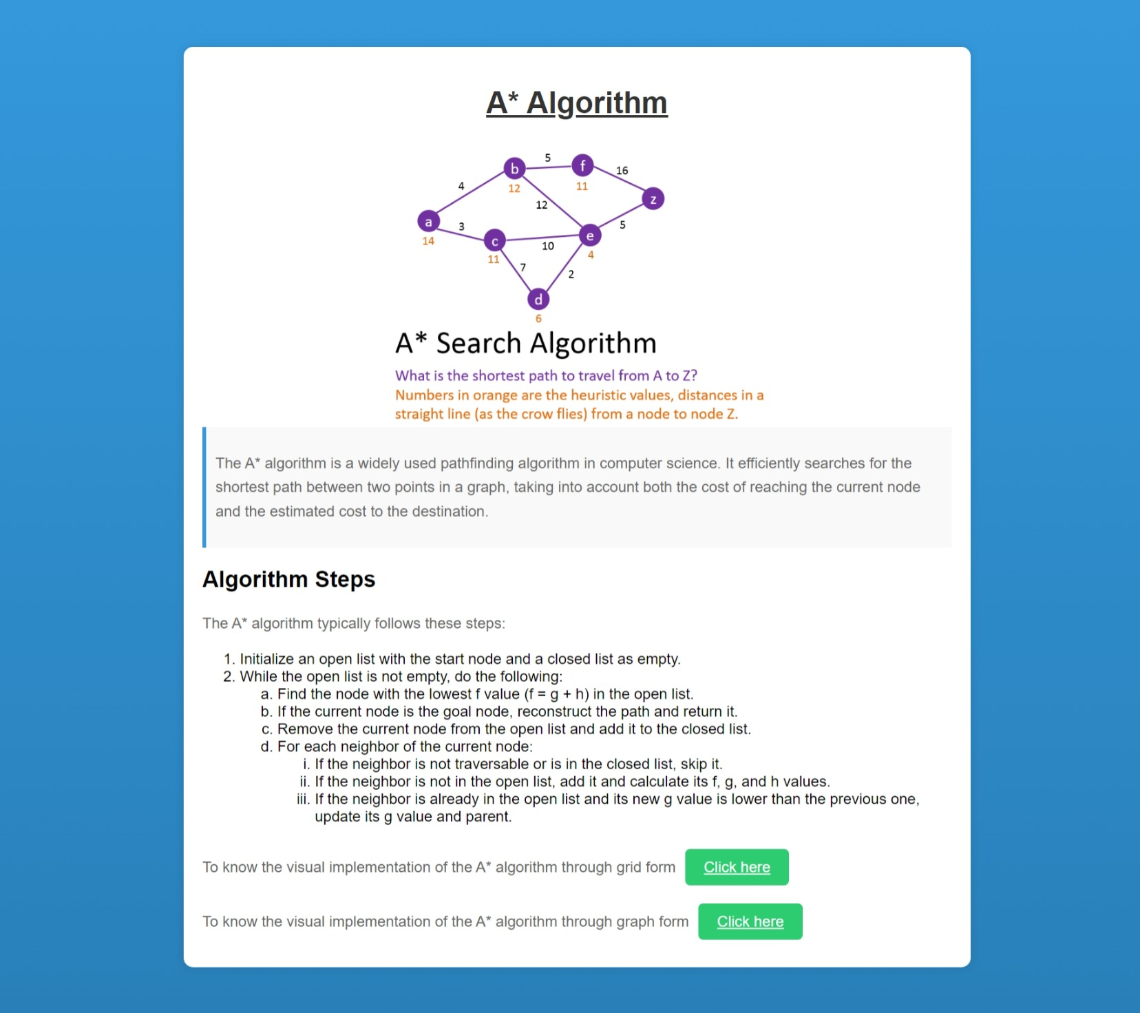
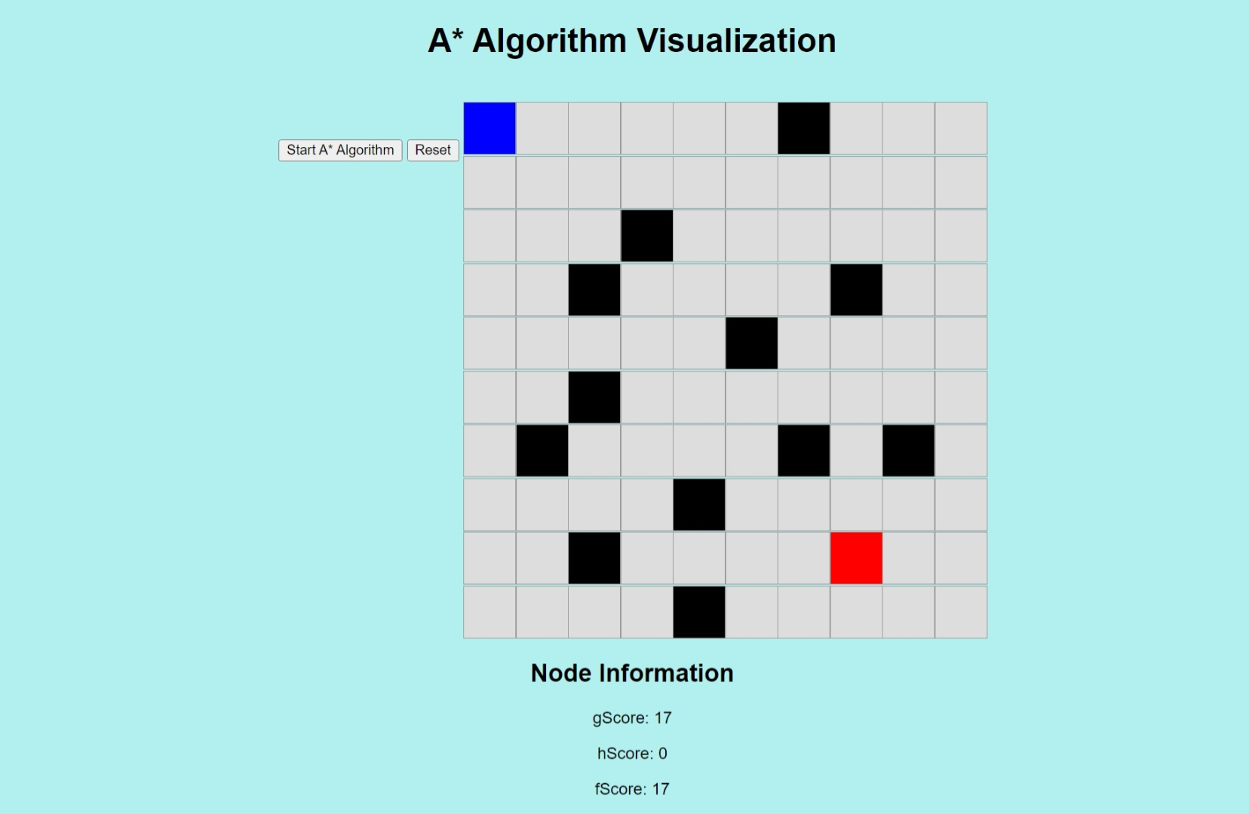
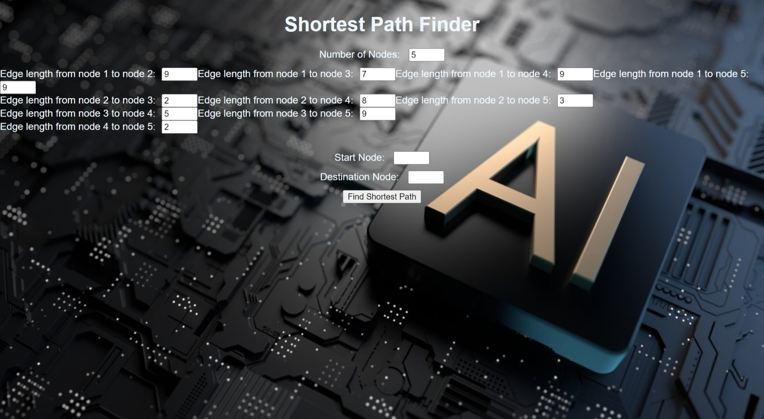
- References
- Wikipedia
- Red Blob Games - A* Tutorial
- AI Junkie - A* Pathfinding for Beginners
- Introduction to A* Algorithm - GeeksforGeeks
- A* Pathfinding Algorithm - Amit’s A* Pages
- A* Pathfinding Algorithm - Khan Academy
- Introduction to A* Algorithm - Coursera

